Name: __________________________ Date: 12/9/16 Period: ___
Group 1
Global 1: The Fall of Rome Timeline: The Death of Marcus Aurelius
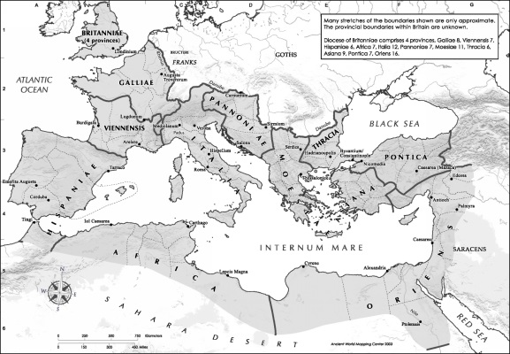
By the second century the Roman Empire had become very unstable and began to fall apart. Many events happened between the decline of the empire and its fall. Read the following information and create a timeline of the events that affected the Roman people as they experienced the collapse of their civilization.
The Roman Empire was one of the largest empires in ancient history but like all the rest, it fell. The Romans conquered all the land around the Mediterranean Sea and called it Mare Nostrum which translates into “our sea”
What body of water did the Roman Empire surround?
____________________________________________________________________________________________________________

During the AD 200s, Germanic tribes successfully attacked the Roman Empire, which was already on the decline. But why? Political unrest, inflation, and a stream of incompetent emperors are cited as causes.
- What did the Germanic tribes of Eastern Europe finally manage to do in the AD 200s?
______________________________________________________________________________________________________________________________________________________
184 AD - Marcus Aurelius, the last of the Good Emperors died and his son Commodus ascended the throne. Marcus Arelius's death came to mark the end of the Pax Romana. As Nero before him, Emperor Commodus squandered (wasted) much of the treasury on his own pleasure and led it into bankruptcy. Without the leadership of Marcus Aurelius, the Roman Civilization began its long decline.
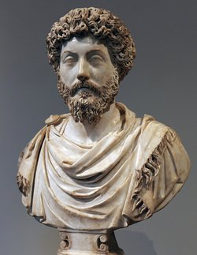
Marcus Aurelius was the last talented ruler that the Romans had for many years. After he died the Roman Empire slowly began to fall apart. Aurelius was known as the “Warrior Philosopher” because he wrote poetry about life while waging war against Rome’s enemies.
When asked about his coming death, Aurelius said “Death smiles at us all, all we can do it smile back.” What did Aurelius mean by this?
___________________________________________________________________________________________________________________________________________________________________________________________________________________________

- What happened to Marcus Aurelius in 184 AD?
______________________________________________________________________________________________________________________________________________________
- How did this affect the Roman Empire?
______________________________________________________________________________________________________________________________________________________
Name: __________________________ Date: 12/9/16 Period: ___
Group 2
Global 1: The Fall of Rome Timeline: The Assassination of Commodus
By the second century the Roman Empire had become very unstable and began to fall apart. Many events happened between the decline of the empire and its fall. Read the following information and create a timeline of the events that affected the Roman people as they experienced the collapse of their civilization.
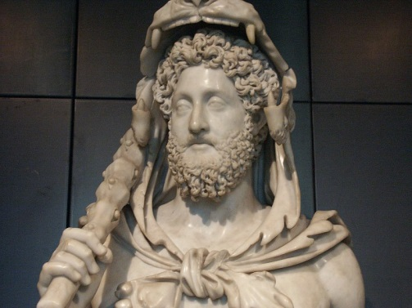
Commodus was the son of the last good emperor of Rome. He constantly refused to rule the country and fought in the Coliseum instead.
What do you think the Roman people thought about Commodus? Why?
_________________________________________________________________________________________________________________________________________________________________________________
192 AD - Commodus’s troops conspired (planned) to assassinate him. He was murdered by his wrestling partner after an unsuccessful poisoning attempt by his mistress, Marcia. An emperor long obsessed with gladiatorial displays, cruelty, and luxury, this was not the first attempt on Commodus’s life. In 183 AD, an attempt had been made at the behest of his sister Lucilla.
Commodus was known to be handsome, dismissive of the Senate, athletic and prone to entering gladiatorial competitions. In 192 AD Commodus was successfully assassinated by his wrestling coach and replaced by a weaker emperor that the senate tried to control.
- Who was Commodus Caesar and what happened to him?
______________________________________________________________________________________________________________________________________________________
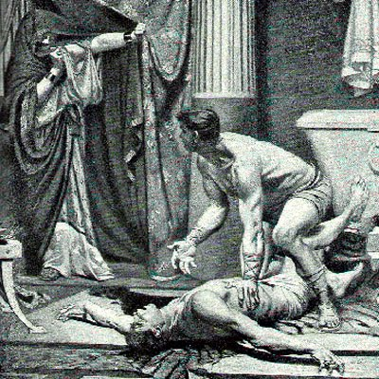
Commodus was assassinated in his bathtub by strangulation in 192 AD. The senate and his family were sick of him and wanted him gone.
Review: What other Roman Emperor was assassinated by the senate?
___________________________________________________________________________________________________________________________

192 AD to 284 AD - Twenty-eight emperors were put into power by the army legions, but most were killed by these same legions. Rome’s armies fought each other and the defense of the empire suffered. Germanic people continuously and successfully attacked the empire. These included tribes like the Saxons, Goths, Alemanni, and the Franks.
- How many emperors ruled Rome’s government between 192 and 284 AD?
____________________________________________________________________________________________________________________________________________________________________
- Who kept killing and replacing the emperors of Rome? What did this do to the defense of the empire?
____________________________________________________________________________________________________________________________________________________________________
Name: __________________________ Date: 12/9/16 Period: ___
Group 3
Global 1: The Fall of Rome Timeline: Diocletian Attempts Reforms
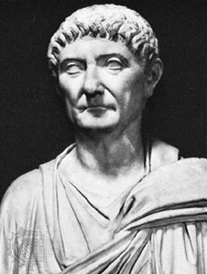
By the second century the Roman Empire had become very unstable and began to fall apart. Many events happened between the decline of the empire and its fall. Read the following information and create a timeline of the events that affected the Roman people as they experienced the collapse of their civilization.
General Diocletian was a reformer like Augustus Caesar. He took control of the Roman government by force in 284 AD and tried to fix the many problems that were causing the empire to fall apart.
Why do you think the empire needed to be reformed and fixed so badly by this point?
__________________________________________________________________________________________________________________________________

284 AD - General Diocletian, after murdering the killer of his predecessor Emperor Carinus, assumed the position of emperor. He instituted many reforms in an effort to stem the invasions and bring political stability back to Rome.
- Increased the number of legions (troops) and toured the empire to inspect its defenses.
- Viewing the Roman Empire as too large for one ruler, Diocletian divided it into two. He became co-emperor of the eastern provinces and installed General Maximian as co-emperor of the western provinces.
- Issued the Edict of Prices in an endeavor (attempt) to control inflation. Emperor Diocletian set a cap on prices and a wage-freeze. A Roman could be put to death for breaking the Edict but, despite this harsh punishment, it failed. Black-markets grew and merchants sold their wares at market prices.
- In an effort to prevent farmers from abandoning their land, he ruled farmers of rented property were never to abandon it.
- Likewise, Romans in heavily taxed occupations were ordered to keep their positions for life.

- Who became emperor of the Roman Empire in 284 AD? What did he do with his power?
____________________________________________________________________________________________________________________________________________________________________________
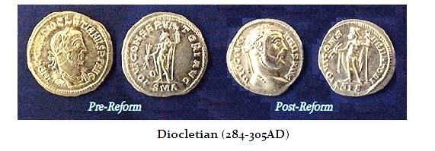
Diocletian tried to fix Rome’s economy by replacing the old gold coins with new silver ones.
Which would you rather have? Gold coins or silver? Why?
_______________________________________________________________________________________________________________________________________________________________________________________

305 AD - Diocletian retired and the Roman government was run by the senate for a short time while a new emperor was selected. During this time they tried to weaken the reforms Diocletian made and increase their own power. They failed.
- What did Diocletian do in 305 AD? Who took over after him and what did they try to do?
_______________________________________________________________________________________________________________________________________________________________________________________________________________________________________
Name: __________________________ Date: 12/9/16 Period: ___
Group 4
Global 1: The Fall of Rome Timeline: Constantine Moves the Capital to Constantinople
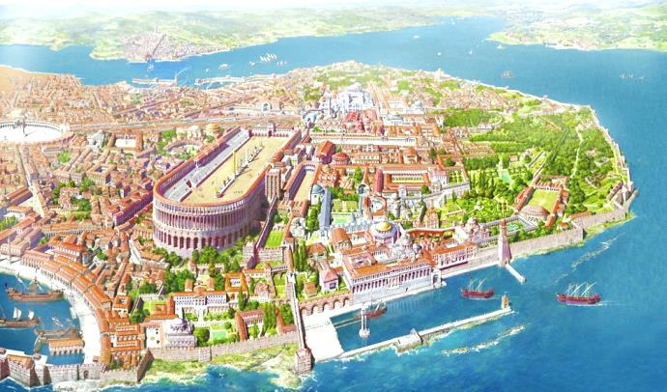
By the second century the Roman Empire had become very unstable and began to fall apart. Many events happened between the decline of the empire and its fall. Read the following information and create a timeline of the events that affected the Roman people as they experienced the collapse of their civilization.
Emperor Constantine took over the Roman government in 312 and moved the capital to a new city in 330. He named it Constantinople and built it on the Bospherus Peninsula.
What was Constantinople surrounded by on three sides that made it easy to protect in 330 AD?
_____________________________________________________________________________________________________________________________________________________________________________

312 AD - Constantine took over as emperor in the east. He tried to reinforce Diocletian’s reforms.
- Made most jobs hereditary, passing from father to son.
- Allowed landowners to actually chain workers to prevent them from leaving.

  - Who came to power in Rome in 312 AD? What did he try to do?
________________________________________________________________________________________________________________________________________________
330 AD - Constantine moved the capital of the eastern empire to Byzantium, a Greek city, and renamed it Constantinople.
  - What did Constantine become famous for in 330 AD?
________________________________________________________________________________________________________________________________________________
337 AD - Death of Constantine. Again, there was civil war until Theodosius I took Constantine’s place. The same problems continued in the empire and had a greater impact in the western half. Theodosius ruled that the empire be split in two upon his death. He believed this would alleviate the empire’s difficulties.
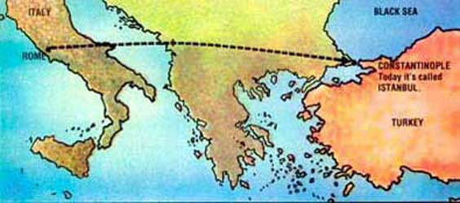
Constantine tried to move the capital of Rome away from all the corruption and war that was hurting the empire but all he did was create two capital cities.
Do you think having two capitals made it easier or harder to run the empire?
______________________________________________________________________________________________________________________
Constantinople

Rome

  - What happened to Constantine in 337 AD? What happened to Rome after that?
________________________________________________________________________________________________________________________________________________
Name: __________________________ Date: 12/9/16 Period: ___
Group 5
Global 1: The Fall of Rome Timeline: The Roman Army is Destroyed
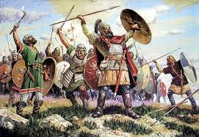
By the second century the Roman Empire had become very unstable and began to fall apart. Many events happened between the decline of the empire and its fall. Read the following information and create a timeline of the events that affected the Roman people as they experienced the collapse of their civilization.
Tribes of German Barbarians had been migrating and living peacefully on Roman land since the year 100 AD but in 300 AD they got fed up with the abusing Roman rule and attacked.
How were the Germans a lot like the Romans when it came to dealing with oppressive rulers? (Think about what the Romans did to Tarquin the proud)
______________________________________________________________________________________________________________________________________________

Late 300s AD - Germanic tribes begin to enter the Roman Empire. Some were in search of wealth, better lands, and a warmer climate; the majority, however, were fleeing ferocious warriors from central Asia known as the Huns. Most tribes comprised numerous warrior groups only loosely connected by language. Roman called these Germanic tribes barbarians because their speech sounded like nonsensical babbling to them.

  - What group of people entered the Roman Empire in 300 AD? Why did most of them come?
_____________________________________________________________________________________________________________________________________________________________________________________________________________________________________________
378 AD - The Visigoths defeated a substantial Roman force at Adrianople in the Balkan Peninsula. The eastern Roman emperor was killed and to maintain peace, his successor turned land in the Balkans over to the Visigoths. After this, the Roman military was no longer an effective fighting force because its best troops were all dead.
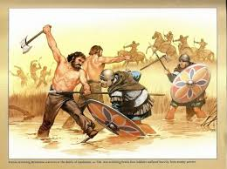
The Roman Army didn’t take the Visigoths seriously in 378 AD and they were defeated in battle by the larger German force.
Have you ever underestimated something you had to do? If so, what?
______________________________________________________________________________________________________________________________________

  - What happened to the Roman military in 378 AD when they tried to attack the Visigoths?
______________________________________________________________________________________________________________________________________________________________
395 AD -The division of the Roman Empire became final. The eastern empire was called the Byzantine Empire by historians while the western half was referred to as the Roman Empire.
  - What happened to the Roman Empire in 395 as a result of the loss of the Roman Army?
_____________________________________________________________________________________________________________________________________________________________________________________________________________________________________________

Name: __________________________ Date: 12/9/16 Period: ___
Group 6
Global 1: The Fall of Rome Timeline: The Sack of Rome
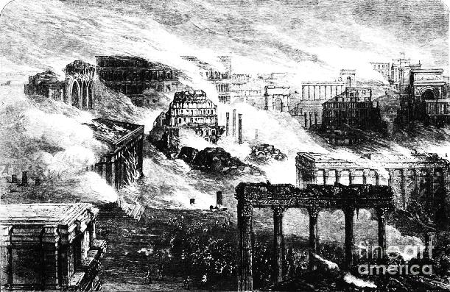
By the second century the Roman Empire had become very unstable and began to fall apart. Many events happened between the decline of the empire and its fall. Read the following information and create a timeline of the events that affected the Roman people as they experienced the collapse of their civilization.
The German tribes that the Romans had mistreated in northern Europe eventually destroyed the city of Rome itself in revenge for their harsh treatment in Gaul and Germany.
Judging by this image, what did the Germans use to destroy Rome?
_________________________________________________________________________________________________________________________________________________________

410 AD - Alaric, a Visigoth chief, captured Rome.
451 AD - The Romans joined forces with the Visigoths to stop the Huns in Gaul. A determined Attila turned to Italy looting and ransacking the cities.
453 AD - Attila the Hun died. The Huns withdrew to Eastern Europe but their absence opened the door to nomadic Germans, Slavs, Persians, and Avars on the eastern border.
- What was happening all over the Roman Empire between 410 AD and 453 AD? How was this different from the Pax Romana?
__________________________________________________________________________________________________________________________________________________________________________________________________________________________________________________________________
455 AD - The Vandals sacked (burned to the ground) the city of Rome. Gaul was taken from Roman control and divided between the Franks and Goths.
- What happened to the city of Rome in 455 AD?
____________________________________________________________________________________________________________________________________________________________________________
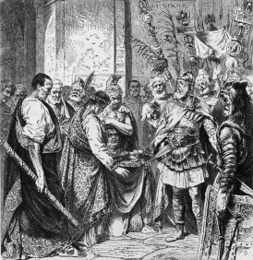
476 AD - The emperor Romulus Augustulus was overthrown by a German soldier named Odoacer who declared himself king. Odoacer did not name a new emperor and so this was commonly referred to as the point when the Roman Empire fell
In 476 AD the last Roman Emperor Romulus Augustus III surrendered to a common German soldier named Odoacer. Odoacer exiled the emperor and named himself the new king of the Italian Peninsula.
How do you think the Romans felt about all this?
______________________________________________________________________________________________________________________________________________________________________________________________

- What happened to the last Roman Emperor? Why did this event cause the official end of the Roman Empire?
____________________________________________________________________________________________________________________________________________________________________________

